**1. Form Validation Assignment:**

**Java Android Program to demonstrate login form with validation.**

Code:activity_main.xml

*<?*xml version="1.0" encoding="utf-8"*?>*<androidx.constraintlayout.widget.ConstraintLayout xmlns:android="http://schemas.android.com/apk/res/android"  
 xmlns:app="http://schemas.android.com/apk/res-auto"  
 xmlns:tools="http://schemas.android.com/tools"  
 android:layout_width="match_parent"  
 android:layout_height="match_parent"  
 android:background="#008000"  
 tools:context=".MainActivity">  
 <RelativeLayout  
 android:layout_width="match_parent"  
 android:layout_height="match_parent"  
 app:layout_constraintEnd_toStartOf="parent"  
 app:layout_constraintTop_toBottomOf="parent">  
 <EditText  
 android:id="@+id/etemail"  
 android:layout_width="300dp"  
 android:layout_height="wrap_content"  
 android:layout_row="0"  
 android:layout_column="0"  
 android:layout_alignParentEnd="true"  
 android:layout_alignParentBottom="true"  
 android:layout_marginEnd="66dp"  
 android:layout_marginRight="50dp"  
 android:layout_marginBottom="511dp"  
 android:background="@color/white"  
 android:ems="10"  
 android:hint="Email"  
 android:inputType="textEmailAddress"  
 tools:layout_editor_absoluteX="74dp"  
 tools:layout_editor_absoluteY="151dp"/>  
 <EditText  
 android:id="@+id/etpassword"  
 android:layout_width="300dp"  
 android:layout_height="wrap_content"  
 android:layout_row="0"  
 android:layout_column="0"  
 android:layout_alignParentEnd="true"  
 android:layout_alignParentBottom="true"  
 android:layout_marginEnd="67dp"  
 android:layout_marginBottom="455dp"  
 android:background="@color/white"  
 android:ems="10"  
 android:hint="Password"  
 android:inputType="textPassword"  
 app:layout_constraintBottom_toBottomOf="parent"  
 tools:layout_editor_absoluteX="74dp" />  
 <Button  
 android:id="@+id/Login"  
 android:layout_width="300dp"  
 android:layout_height="wrap_content"  
 android:layout_row="0"  
 android:layout_column="0"  
 android:layout_alignParentStart="true"  
 android:layout_alignParentEnd="true"  
 android:layout_alignParentBottom="true"  
 android:layout_marginStart="63dp"  
 android:layout_marginEnd="48dp"  
 android:layout_marginBottom="359dp"  
 android:background="@color/white"  
 android:text="Login"  
 android:textColor="#90EE90"  
 app:layout_constraintBottom_toBottomOf="parent"  
 tools:layout_editor_absoluteY="74dp"/>  
 <TextView  
 android:id="@+id/tvresult"  
 android:layout_width="wrap_content"  
 android:layout_height="wrap_content"  
 android:layout_row="0"  
 android:layout_column="0"  
 android:layout_alignParentStart="true"  
 android:layout_alignParentEnd="true"  
 android:layout_alignParentBottom="true"  
 android:layout_marginStart="74dp"  
 android:layout_marginEnd="59dp"  
 android:layout_marginBottom="278dp"  
 android:text="Not a member?Sign Up now."  
 android:textAppearance="?android:attr/textAppearanceLarge"  
 android:textColor="@color/white"  
 android:textStyle="italic"  
 app:layout_constraintBottom_toBottomOf="parent"  
 app:layout_constraintTop_toTopOf="parent"  
 app:layout_constraintVertical_bias="0.529"  
 tools:layout_editor_absoluteX="74dp"/>  
 <TextView  
 android:id="@+id/textView2"  
 android:layout_width="219dp"  
 android:layout_height="153dp"  
 android:layout_row="0"  
 android:layout_column="0"  
 android:layout_alignParentStart="true"  
 android:layout_alignParentEnd="true"  
 android:layout_alignParentBottom="true"  
 android:layout_marginStart="99dp"  
 android:layout_marginEnd="93dp"  
 android:layout_marginBottom="102dp"  
 android:text=""  
 android:textSize="16dp"  
 app:layout_constraintBottom_toBottomOf="parent"  
 app:layout_constraintEnd_toEndOf="parent"  
 app:layout_constraintHorizontal_bias="0.528"  
 app:layout_constraintStart_toStartOf="parent"/>  
 </RelativeLayout>  
</androidx.constraintlayout.widget.ConstraintLayout>

Code : MainActivity.java

package com.example.myapplication;  
  
import androidx.appcompat.app.AppCompatActivity;  
  
import android.view.View;  
import android.widget.TextView;  
import android.widget.EditText;  
import android.widget.Button;  
import android.os.Bundle;  
  
public class MainActivity extends AppCompatActivity {  
 EditText email,password;  
 TextView result;  
 Button login1;  
  
 @Override  
 protected void onCreate(Bundle savedInstanceState) {  
 super.onCreate(savedInstanceState);  
 setContentView(R.layout.*activity_main*);  
 email=(EditText) findViewById(R.id.*etemail*);  
 password=(EditText) findViewById(R.id.*etpassword*);  
 result=(TextView)findViewById(R.id.*tvresult*);  
 login1=(Button) findViewById(R.id.*Login*);  
 login1.setOnClickListener(new View.OnClickListener() {  
 @Override  
 public void onClick(View v) {  
 String e1=email.getText().toString();  
 String e2=password.getText().toString();  
 result.setText("Email\t:" +e1+"\nPassword\t:"+e2);  
  
 }  
 });  
 }  
 }

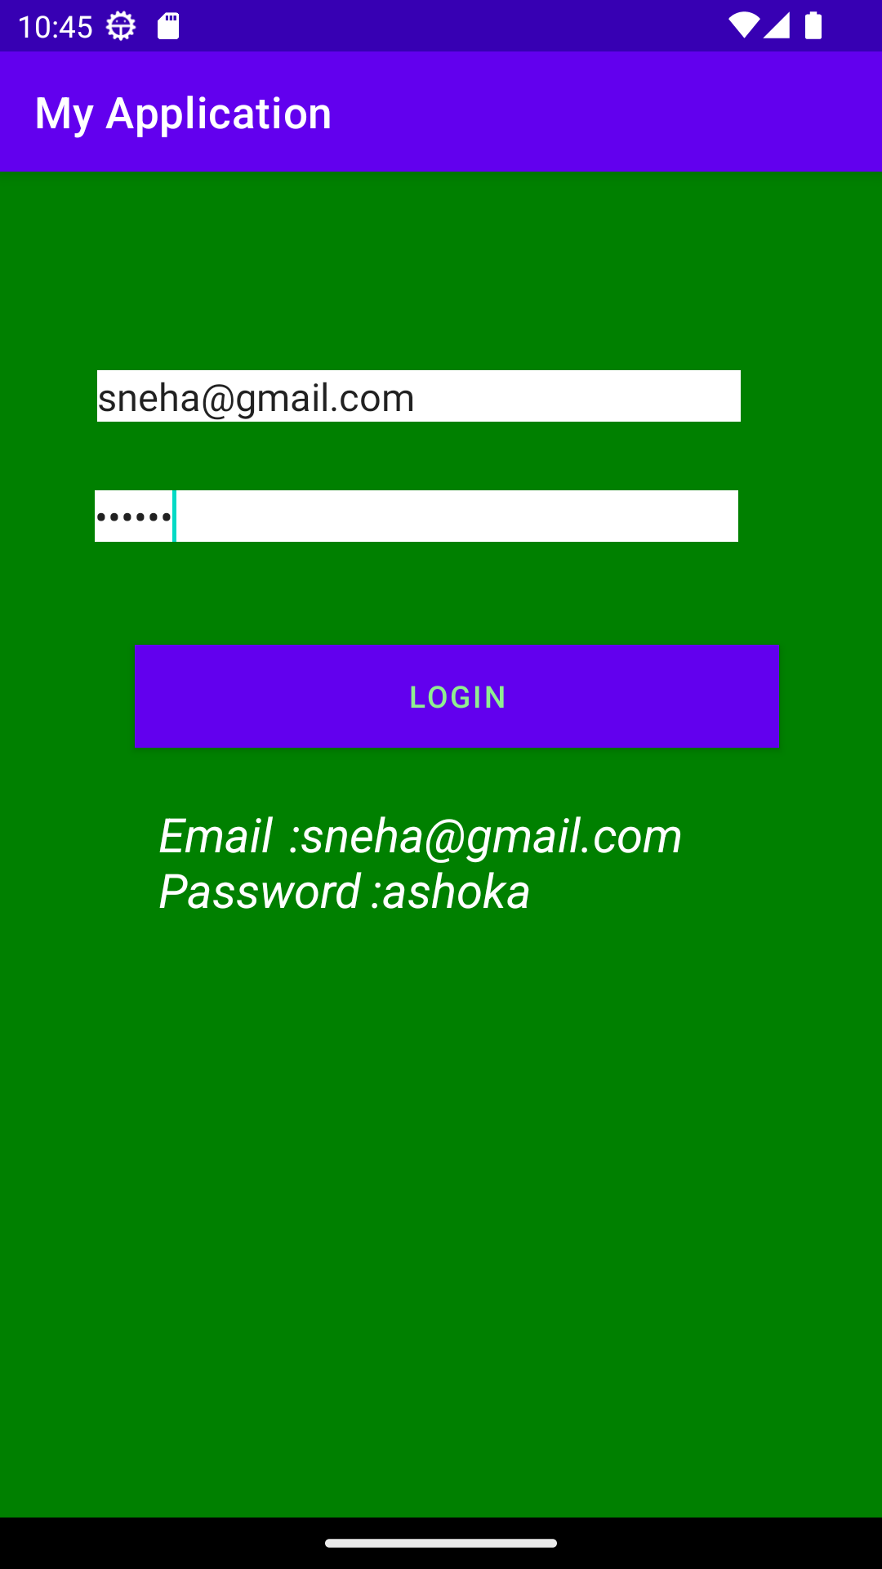

**2. Create registration form given below. Also perform appropriate validation.**

Code:activity_main.xml

*<?*xml version="1.0" encoding="utf-8"*?>*<RelativeLayout xmlns:android="http://schemas.android.com/apk/res/android"  
 xmlns:app="http://schemas.android.com/apk/res-auto"  
 xmlns:tools="http://schemas.android.com/tools"  
 android:layout_width="match_parent"  
 android:layout_height="match_parent"  
 tools:context=".MainActivity">  
  
 <EditText  
 android:id="@+id/editTextUsername"  
 android:layout_width="300dp"  
 android:layout_height="wrap_content"  
 android:layout_alignParentEnd="true"  
 android:layout_alignParentBottom="true"  
 android:layout_marginTop="25dp"  
 android:layout_marginEnd="71dp"  
 android:layout_marginBottom="515dp"  
 android:hint="Name"  
 android:inputType="textPersonName"/>  
  
 <EditText  
 android:id="@+id/editTextEmail"  
 android:layout_width="300dp"  
 android:layout_height="wrap_content"  
 android:layout_alignParentStart="true"  
 android:layout_alignParentEnd="true"  
 android:layout_alignParentBottom="true"  
 android:layout_marginStart="36dp"  
 android:layout_marginTop="15dp"  
 android:layout_marginEnd="73dp"  
 android:layout_marginBottom="448dp"  
 android:hint="E-mail"  
 android:inputType="textEmailAddress"/>  
  
 <EditText  
 android:id="@+id/editTextPassword"  
 android:layout_width="300dp"  
 android:layout_height="wrap_content"  
 android:layout_alignParentStart="true"  
 android:layout_alignParentEnd="true"  
 android:layout_alignParentBottom="true"  
 android:layout_marginStart="37dp"  
 android:layout_marginTop="15dp"  
 android:layout_marginEnd="73dp"  
 android:layout_marginBottom="385dp"  
 android:hint="Password"  
 android:inputType="textPassword"/>  
  
 <EditText  
 android:id="@+id/editTextAge"  
 android:layout_width="299dp"  
 android:layout_height="55dp"  
 android:layout_alignParentStart="true"  
 android:layout_alignParentEnd="true"  
 android:layout_alignParentBottom="true"  
 android:layout_marginStart="38dp"  
 android:layout_marginTop="15dp"  
 android:layout_marginEnd="74dp"  
 android:layout_marginBottom="304dp"  
 android:hint="Age"  
 android:inputType="number"/>  
  
 <EditText  
 android:id="@+id/editTextMobile"  
 android:layout_width="299dp"  
 android:layout_height="55dp"  
 android:layout_alignParentStart="true"  
 android:layout_alignParentEnd="true"  
 android:layout_alignParentBottom="true"  
 android:layout_marginStart="43dp"  
 android:layout_marginTop="15dp"  
 android:layout_marginEnd="69dp"  
 android:layout_marginBottom="232dp"  
 android:hint="Mobile No"  
 android:inputType="phone"/>  
  
 <Button  
 android:id="@+id/button1"  
 android:layout_width="300dp"  
 android:layout_height="wrap_content"  
 android:layout_alignParentEnd="true"  
 android:layout_alignParentBottom="true"  
 android:layout_marginTop="15dp"  
 android:layout_marginEnd="66dp"  
 android:layout_marginBottom="164dp"  
 android:text="Register" />  
  
</RelativeLayout>

Code:MainActivity.java

package com.example.myapplication;  
  
import androidx.appcompat.app.AppCompatActivity;  
  
import android.os.Bundle;  
import android.content.Intent;  
import android.widget.Button;  
import android.widget.EditText;  
import android.view.View;  
import android.widget.Toast;  
  
public class MainActivity extends AppCompatActivity {  
 EditText name;  
 EditText password;  
 EditText email;  
 EditText age;  
 EditText mbno;  
 Button submit;  
 boolean ischecked=false;  
 @Override  
 protected void onCreate(Bundle savedInstanceState) {  
 super.onCreate(savedInstanceState);  
 setContentView(R.layout.*activity_main*);  
 name=(EditText) findViewById(R.id.*editTextUsername*);  
 email=(EditText) findViewById(R.id.*editTextEmail*);  
 password=(EditText) findViewById(R.id.*editTextPassword*);  
 age=(EditText) findViewById(R.id.*editTextAge*);  
 mbno=(EditText) findViewById(R.id.*editTextMobile*);  
 submit=(Button) findViewById(R.id.*button1*);  
 submit.setOnClickListener(new View.OnClickListener() {  
 @Override  
 public void onClick(View v) {  
 name.requestFocus();  
 if(name.length()==0){  
 name.setError("This field is required");  
 name.requestFocus();  
 }  
 else if(email.length()==0){  
 email.setError("Email is required");  
 email.requestFocus();  
 }  
 else if(password.length()==0||password.length()<8){  
 password.setError("Invalid password enter 8 more");  
 password.requestFocus();  
 }  
 else if(age.getText().toString().isEmpty())  
 {  
 age.setError("Invalid Age");  
 age.requestFocus();  
 }  
 else if(mbno.length()==0||mbno.length()<10){  
 mbno.setError("Invalid phone number");  
 mbno.requestFocus();  
 }  
 else{  
 Toast.*makeText*(getApplicationContext(),"Valid user",Toast.*LENGTH_LONG*).show();  
 }  
 }  
 });  
  
 }  
 }

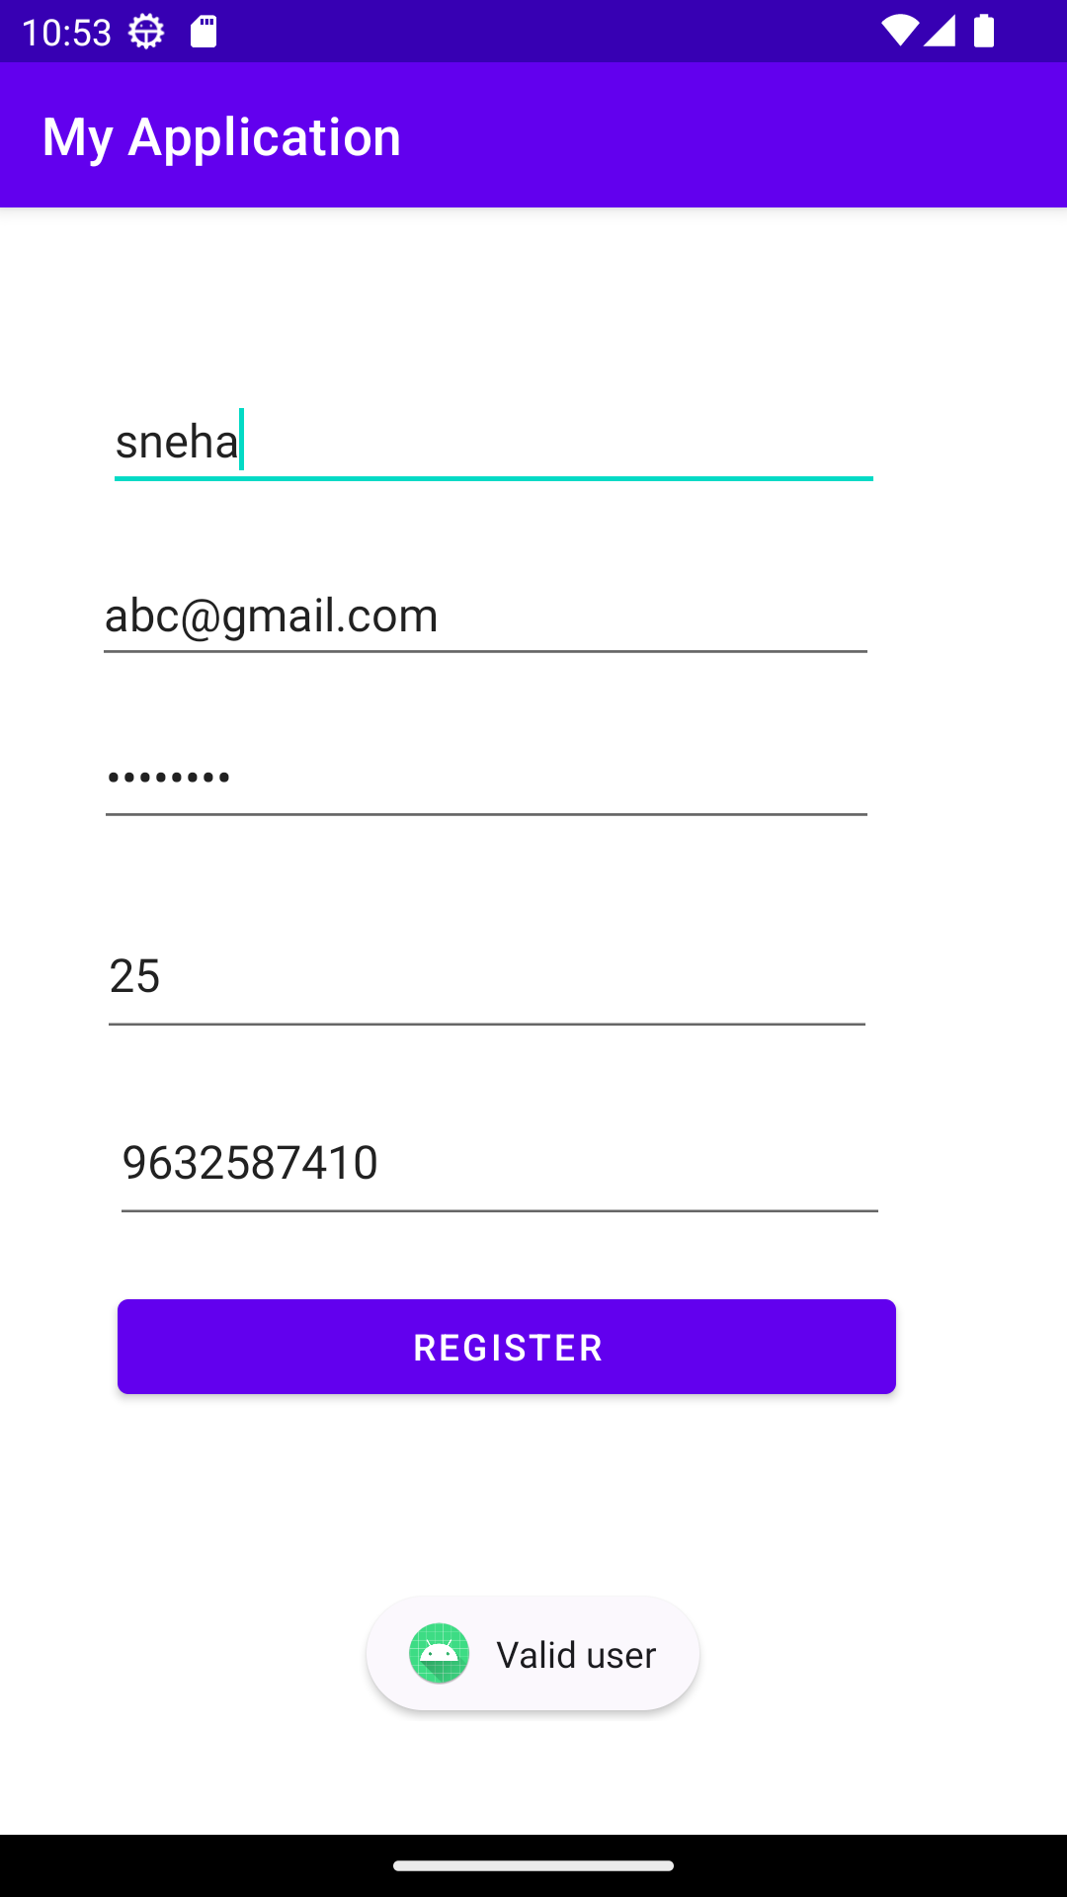

**3. Assignment on Toast Message:  
Design android application for login activity. Write android  
code to check login credentials with username = "mca" and password =  
"android". Display appropriate toast message to the user.**

Code:activity_main.xml

*<?*xml version="1.0" encoding="utf-8"*?>*<androidx.constraintlayout.widget.ConstraintLayout xmlns:android="http://schemas.android.com/apk/res/android"  
 xmlns:app="http://schemas.android.com/apk/res-auto"  
 xmlns:tools="http://schemas.android.com/tools"  
 android:layout_width="match_parent"  
 android:layout_height="match_parent"  
 android:background="#87CEEB"  
 tools:context=".MainActivity">  
  
 <LinearLayout  
 android:layout_width="match_parent"  
 android:layout_height="match_parent"  
 android:orientation="vertical"  
 android:padding="16dp">  
 <EditText  
 android:id="@+id/usernameET"  
 android:layout_width="match_parent"  
 android:layout_height="wrap_content"  
 android:hint="Username"  
 android:inputType="text"/>  
 <EditText  
 android:id="@+id/passwordET"  
 android:layout_width="match_parent"  
 android:layout_height="wrap_content"  
 android:hint="Password"  
 android:inputType="textPassword"/>  
 <Button  
 android:id="@+id/loginBtn"  
 android:layout_width="match_parent"  
 android:layout_height="wrap_content"  
 android:text="Login"/>  
 </LinearLayout>  
</androidx.constraintlayout.widget.ConstraintLayout>

Code:MainActivity.java

package com.example.myapplication;  
import android.widget.EditText;  
import android.widget.Button;  
import android.view.View;  
import android.widget.Toast;  
import android.os.Bundle;  
import androidx.appcompat.app.AppCompatActivity;  
public class MainActivity extends AppCompatActivity {  
 EditText usernameEditText;  
 EditText passwordEditText;  
 Button loginButton;  
 @Override  
 protected void onCreate(Bundle savedInstanceState) {  
 super.onCreate(savedInstanceState);  
 setContentView(R.layout.*activity_main*);  
 usernameEditText = findViewById(R.id.*usernameET*);  
 passwordEditText = findViewById(R.id.*passwordET*);  
 loginButton = findViewById(R.id.*loginBtn*);  
 loginButton.setOnClickListener(new View.OnClickListener() {  
 @Override  
 public void onClick(View v) {  
 String username = usernameEditText.getText().toString().trim();  
 String password = passwordEditText.getText().toString().trim();  
 checkLoginCreditials(username, password);  
 }  
 });  
 }  
  
 private void checkLoginCreditials(String username, String password) {  
 String validUsername = "mca";  
 String validPassword = "android";  
 if (username.equals(validUsername) && password.equals(validPassword)) {  
 Toast.*makeText*(this, "Login Successful", Toast.*LENGTH_SHORT*).show();  
 } else {  
 Toast.*makeText*(this, "Invalid Username or password", Toast.*LENGTH_SHORT*).show();  
 }  
 }  
}

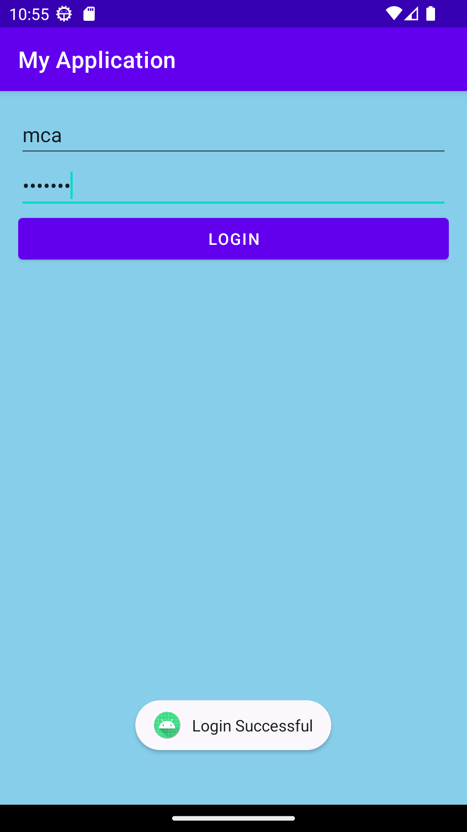

**4. Create the simple calculator shown below also perform appropriate operation.**

Code:activity_main.xml

*<?*xml version="1.0" encoding="utf-8"*?>*<TableLayout xmlns:android="http://schemas.android.com/apk/res/android"  
 xmlns:app="http://schemas.android.com/apk/res-auto"  
 xmlns:tools="http://schemas.android.com/tools"  
 android:layout_width="match_parent"  
 android:layout_height="match_parent"  
 tools:context=".MainActivity">  
 <EditText  
 android:id="@+id/e1"  
 android:layout_width="match_parent"  
 android:layout_height="wrap_content"  
 android:layout_marginTop="25dp"  
 android:layout_marginLeft="15dp"  
 android:layout_marginRight="15dp"/>  
 <TableRow  
 android:layout_width="wrap_content"  
 android:layout_height="wrap_content"  
 android:layout_marginTop="15dp"  
 android:layout_marginRight="15dp"  
 android:layout_marginLeft="15dp">  
 <Button  
 android:layout_width="60dp"  
 android:layout_height="wrap_content"  
 android:id="@+id/b1"  
 android:text="1"  
 android:layout_marginLeft="5dp"  
 android:layout_column="0"/>  
 <Button  
 android:layout_width="60dp"  
 android:layout_height="wrap_content"  
 android:id="@+id/b2"  
 android:text="2"  
 android:layout_marginLeft="5dp"  
 android:layout_column="1"/>  
 <Button  
 android:layout_width="60dp"  
 android:layout_height="wrap_content"  
 android:id="@+id/b3"  
 android:text="3"  
 android:layout_marginLeft="5dp"  
 android:layout_column="2"/>  
 <Button  
 android:layout_width="90dp"  
 android:layout_height="wrap_content"  
 android:id="@+id/badd"  
 android:text="+"  
 android:layout_marginLeft="90dp"  
 android:layout_column="3"/>  
 </TableRow>  
 <TableRow  
 android:layout_width="wrap_content"  
 android:layout_height="wrap_content"  
 android:layout_marginTop="15dp"  
 android:layout_marginRight="15dp"  
 android:layout_marginLeft="15dp">  
 <Button  
 android:layout_width="60dp"  
 android:layout_height="wrap_content"  
 android:id="@+id/b4"  
 android:text="4"  
 android:layout_marginLeft="5dp"  
 android:layout_column="0"/>  
 <Button  
 android:layout_width="60dp"  
 android:layout_height="wrap_content"  
 android:id="@+id/b5"  
 android:text="5"  
 android:layout_marginLeft="5dp"  
 android:layout_column="1"/>  
 <Button  
 android:layout_width="60dp"  
 android:layout_height="wrap_content"  
 android:id="@+id/b6"  
 android:text="6"  
 android:layout_marginLeft="5dp"  
 android:layout_column="2"/>  
 <Button  
 android:layout_width="90dp"  
 android:layout_height="wrap_content"  
 android:id="@+id/bsub"  
 android:text="-"  
 android:layout_marginLeft="90dp"  
 android:layout_column="3"/>  
 </TableRow>  
 <TableRow  
 android:layout_width="wrap_content"  
 android:layout_height="wrap_content"  
 android:layout_marginTop="15dp"  
 android:layout_marginRight="15dp"  
 android:layout_marginLeft="15dp">  
 <Button  
 android:layout_width="60dp"  
 android:layout_height="wrap_content"  
 android:id="@+id/b7"  
 android:text="7"  
 android:layout_marginLeft="5dp"  
 android:layout_column="0"/>  
 <Button  
 android:layout_width="60dp"  
 android:layout_height="wrap_content"  
 android:id="@+id/b8"  
 android:text="8"  
 android:layout_marginLeft="5dp"  
 android:layout_column="1"/>  
 <Button  
 android:layout_width="60dp"  
 android:layout_height="wrap_content"  
 android:id="@+id/b9"  
 android:text="9"  
 android:layout_marginLeft="5dp"  
 android:layout_column="2"/>  
 <Button  
 android:layout_width="90dp"  
 android:layout_height="wrap_content"  
 android:id="@+id/bmul"  
 android:text="*"  
 android:layout_marginLeft="90dp"  
 android:layout_column="3"/>  
 </TableRow>  
 <TableRow  
 android:layout_width="wrap_content"  
 android:layout_height="wrap_content"  
 android:layout_marginTop="15dp"  
 android:layout_marginRight="15dp"  
 android:layout_marginLeft="15dp">  
 <Button  
 android:layout_width="60dp"  
 android:layout_height="wrap_content"  
 android:id="@+id/bdot"  
 android:text="."  
 android:layout_marginLeft="5dp"  
 android:layout_column="0"/>  
 <Button  
 android:layout_width="60dp"  
 android:layout_height="wrap_content"  
 android:id="@+id/bzero"  
 android:text="0"  
 android:layout_marginLeft="5dp"  
 android:layout_column="1"/>  
 <Button  
 android:layout_width="60dp"  
 android:layout_height="wrap_content"  
 android:id="@+id/bclear"  
 android:text="C"  
 android:layout_marginLeft="5dp"  
 android:layout_column="2"/>  
 <Button  
 android:layout_width="90dp"  
 android:layout_height="wrap_content"  
 android:id="@+id/bdiv"  
 android:text="/"  
 android:layout_marginLeft="90dp"  
 android:layout_column="3"/>  
 </TableRow>  
 <Button  
 android:id="@+id/bequal"  
 android:text="="  
 android:layout_marginLeft="15dp"  
 android:layout_marginTop="15dp"  
 android:layout_marginRight="15dp"/>  
</TableLayout>

Code:MainActivity.java

package com.example.calculator_table;  
  
import androidx.appcompat.app.AppCompatActivity;  
  
import android.os.Bundle;  
import android.widget.Button;  
import android.widget.EditText;  
import android.view.View;  
  
public class MainActivity extends AppCompatActivity {  
 EditText e1;  
 Button button0,button1,button2,button3,button4,button5,button6,button7,button8,button9,buttondot,buttonclear,buttonadd,buttonsub,buttonmul,buttondiv,buttonequal;  
 float one,two;  
 boolean add,mul,div,sub;  
  
 @Override  
 protected void onCreate(Bundle savedInstanceState) {  
 super.onCreate(savedInstanceState);  
 setContentView(R.layout.*activity_main*);  
 e1=(EditText)findViewById(R.id.*e1*);  
 button0=(Button)findViewById (R.id.*bzero*);  
 button1=(Button)findViewById (R.id.*b1*);  
 button2=(Button)findViewById (R.id.*b2*);  
 button3=(Button)findViewById (R.id.*b3*);  
 button4=(Button)findViewById (R.id.*b4*);  
 button5=(Button)findViewById (R.id.*b5*);  
 button6=(Button)findViewById (R.id.*b6*);  
 button7=(Button)findViewById (R.id.*b7*);  
 button8=(Button)findViewById (R.id.*b8*);  
 button9=(Button)findViewById (R.id.*b9*);  
 buttonadd=(Button)findViewById(R.id.*badd*);  
 buttonsub=(Button)findViewById(R.id.*bsub*);  
 buttonmul=(Button)findViewById(R.id.*bmul*);  
 buttondiv=(Button)findViewById(R.id.*bdiv*);  
 buttonclear=(Button)findViewById(R.id.*bclear*);  
 buttonequal=(Button)findViewById(R.id.*bequal*);  
 buttondot=(Button)findViewById(R.id.*bdot*);  
  
 button1.setOnClickListener(new View.OnClickListener(){  
 @Override  
 public void onClick(View v){  
 e1.setText(e1.getText()+"1");  
 }  
 });  
 button2.setOnClickListener(new View.OnClickListener(){  
 @Override  
 public void onClick(View v){  
 e1.setText(e1.getText()+"2");  
 }  
 });  
 button3.setOnClickListener(new View.OnClickListener(){  
 @Override  
 public void onClick(View v){  
 e1.setText(e1.getText()+"3");  
 }  
 });  
 button4.setOnClickListener(new View.OnClickListener(){  
 @Override  
 public void onClick(View v){  
 e1.setText(e1.getText()+"4");  
 }  
 });  
 button5.setOnClickListener(new View.OnClickListener(){  
 @Override  
 public void onClick(View v){  
 e1.setText(e1.getText()+"5");  
 }  
 });  
 button6.setOnClickListener(new View.OnClickListener(){  
 @Override  
 public void onClick(View v){  
 e1.setText(e1.getText()+"6");  
 }  
 });  
 button7.setOnClickListener(new View.OnClickListener(){  
 @Override  
 public void onClick(View v){  
 e1.setText(e1.getText()+"7");  
 }  
 });  
 button8.setOnClickListener(new View.OnClickListener(){  
 @Override  
 public void onClick(View v){  
 e1.setText(e1.getText()+"8");  
 }  
 });  
 button9.setOnClickListener(new View.OnClickListener(){  
 @Override  
 public void onClick(View v){  
 e1.setText(e1.getText()+"9");  
 }  
 });  
 button0.setOnClickListener(new View.OnClickListener(){  
 @Override  
 public void onClick(View v){  
 e1.setText(e1.getText()+"0");  
 }  
 });  
 buttonadd.setOnClickListener(new View.OnClickListener(){  
 @Override  
 public void onClick(View v){  
 if(e1==null) {  
 e1.setText("");  
 }else{  
 one=Float.*parseFloat*(e1.getText()+"");  
 add=true;  
 e1.setText(null);  
 }  
 }  
 });  
 buttonsub.setOnClickListener(new View.OnClickListener(){  
 @Override  
 public void onClick(View v){  
  
 one=Float.*parseFloat*(e1.getText()+"");  
 sub=true;  
 e1.setText(null);  
 }  
 });  
 buttonmul.setOnClickListener(new View.OnClickListener(){  
 @Override  
 public void onClick(View v){  
  
 one=Float.*parseFloat*(e1.getText()+"");  
 mul=true;  
 e1.setText(null);  
 }  
 });  
 buttondiv.setOnClickListener(new View.OnClickListener(){  
 @Override  
 public void onClick(View v){  
  
 one=Float.*parseFloat*(e1.getText()+"");  
 div=true;  
 e1.setText(null);  
 }  
 });  
 buttonequal.setOnClickListener(new View.OnClickListener(){  
 @Override  
 public void onClick(View v) {  
  
 two = Float.*parseFloat*(e1.getText() + "");  
 if (add == true) {  
 e1.setText(one + two + "");  
 add = false;  
 }  
 if (sub == true) {  
 e1.setText(one - two + "");  
 sub = false;  
 }  
 if (mul== true) {  
 e1.setText(one * two + "");  
 mul= false;  
 }  
 if (div == true) {  
 e1.setText(one / two + "");  
 div = false;  
 }  
 }  
 });  
 buttonclear.setOnClickListener(new View.OnClickListener() {  
 @Override  
 public void onClick(View view) { e1.setText("");}  
 });  
 buttondot.setOnClickListener(new View.OnClickListener() {  
 @Override  
 public void onClick(View view) {e1.setText(e1.getText()+"");}  
  
 });  
  
 }  
}

